**Lab Session 12: Flip-Flop**

**OBJECTIVES:**

* Design D Flip-Flop, JK Flip Flop and verify their functional characteristics
* Define ‘Set’, ‘Reset’, ‘Preset’ and ‘Clear’ concepts in Flip-Flops
* Extract information of flip-flop from its timing diagram

**APPARATUS:** Logic trainer, Logic probe

**COMPONENTS:** ICs 74LS08, 74LS32, 74LS04, 74LS86, 74LS02

## Flip-Flop

In digital circuits, a ***flip-flop*** is a term referring to an electronic circuit (a bistable multivibrator) that has two stable states 0 and 1. A flip-flop is a memory device and thus will store a value while power remains in the circuit. Storage elements that operate with signal levels (rather than signal transitions) are referred to as latches; those controlled by a **clock transition** are flip-flops. Latches are said to be level sensitive devices; flip-flops are edge-sensitive devices. Both are the simplest examples if ***sequential systems***.

## **Symbol for Flip-Flop**

A general type of symbol used for a flip-flop is shown in Figure.1. It has multiple inputs, and two outputs labeled Q & Q’ which are the inverse of each other. The Q output is called the ***normal output*** and Q’ is the ***inverted output***. If we say that the flip-flop is in the High-state, we mean that Q = 1 & if we say that a flip-flop is in Low-state we mean that Q = 0 of course, the Q’ state will always be the inverse of Q.

The high state i.e., Q = 1 & Q’ = 0 of a Flip – flop is also known as **SET** state. The low state

i.e., Q = 0 & Q’ = 1 is then called **RESET** state. The **reset state** is also called the **clear state**.

Set 1 high state

Reset 0 clear pin

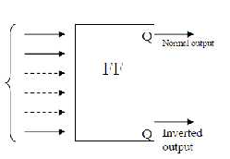

Figure.1 Symbol for Flip-Flop

# Edge Triggered D-Flip-Flop

One method of enabling a multivibrator circuit is called edge triggering, where the circuit’s data inputs have control only during the time that the enable input is transitioning from one state to another. Let’s compare timing diagrams for a normal D latch versus one that is edge-triggered:

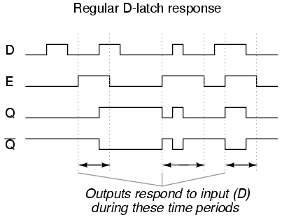

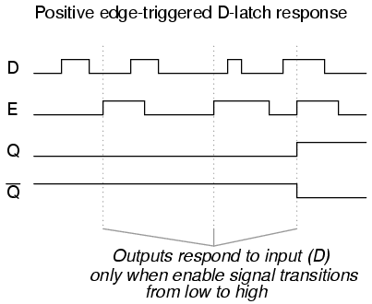

 In the first timing diagram, the outputs respond to input D whenever the enable (E) input is high, for however long it remains high. When the enable signal falls back to a low state, the circuit remains latched.

In the second timing diagram, we note a distinctly different response in the circuit output(s): it only responds to the D input during that brief moment of time when the enable signal changes, or transitions, from low to high. This is known as positive edge-triggering.

There is such a thing as negative edge triggering as well, and it produces the following response to the same input signals:

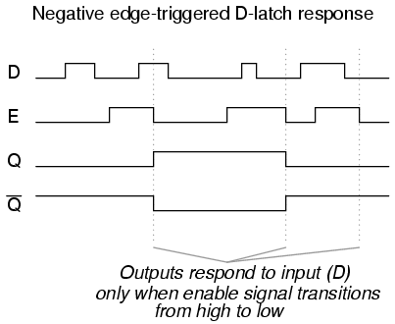

Whenever we enable a multivibrator circuit on the transitional edge of a square-wave enable signal, we call it a flip-flop instead of a latch. Consequently, and edge-triggered S-R circuit is more properly known as an S-R flip-flop, and an edge-triggered D circuit as a D flip-flop

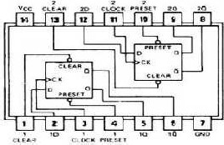 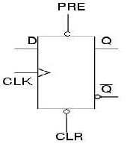

Figure.2 IC 74LS74PinConfiguration Figure.3 Graphic symbol Dflip-flop

**Function Table of D Flip-Flop**

|  |  |  |  |  |  |  |
| --- | --- | --- | --- | --- | --- | --- |
| **Inputs** | | | | **Outputs** | | **Comments** |
| **D** | **CLK** | **Preset** | **Clear** | **Q** | **Q’** |
|  |  |  |  |  |  |  |
| 1 | 1 | O |  |  |  |  |
|  | 1 |  |  |  |  |  |
|  | 1 |  |  |  |  |  |
|  | 1 |  |  |  |  |  |

* 1. **JK flip-flop**

The JK type flip-flop consists of two data inputs: J and K, and one clock input. There are again two outputs Q and Q' (where Q' is the reverse of Q). toggle

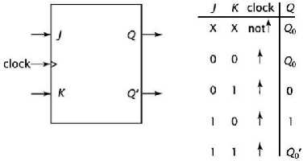

**Lab Task #1**

**Implement JK flip- flop by using logic gates.**

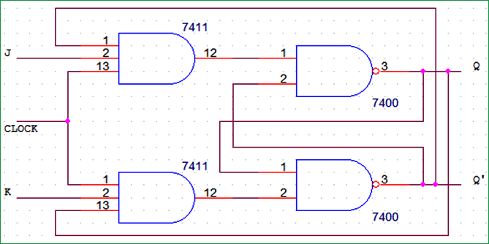

**Lab Task #2**

